ASSP Hudson River Valley Chapter Meeting Minutes
May 7, 2020 – Chapter Board Meeting
Teleconference Call – ZOOM Platform.
1 – Chapter Board Meeting was called to order at 5:35 P.M.
2 – Board Members on the teleconference call were: Matthew McDonald; Josephine McCaffrey; Ken Eck; Curt Jones; Susanne May; David Zaremsky; Jim Foley; Jim Bohren; Tom Lowe; Charles Von Dietsch.
3 - Election Cycle is upon us again for Chapter Officers. The slate of candidates below will be presented to Chapter members if accepted by the Board at this meeting. Those candidates are as follows:
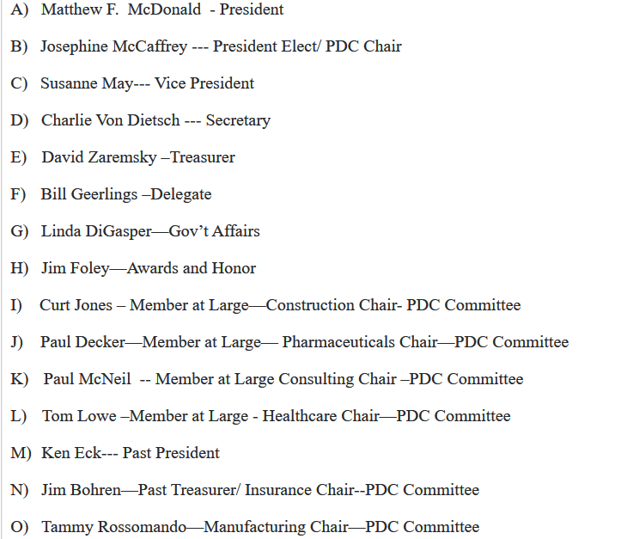
This slate of candidates for the offices so named was accepted by motion of Chapter President Matthew F. McDonald, and was seconded by Board Member Curt Jones. Board Members on the call agreed by a roll call voice vote to accept the slate as presented. The above slate of candidates will be presented to the General Membership for official vote during the Month of May, and be closed out on May 31, 2020.
4 – Matthew McDonald stated that he is working on a change to the Chapter By-Laws. He will send out to the Board members to discuss and vote on Acceptance as soon as it is complete. Matthew has stated that he had contacted the National organization and informed them of the planned changes as modeled on the By-Laws of the New Jersey Chapter.
5 – Chapter Treasurer David Zaremsky gave a report on the financials of the Chapter for the operational year-to-date. The Chapter is financially sound near the end of the operational year.
6 – A discussion was held on granting the status of Chapter Honorary Membership for Peter Bryne who is the Safety Compliance & Fire Safety Coordinator for the Rockland County Fire Training Center in Pomona, NY. After the discussion the motion was made in favor of this status by Curt Jones. It was seconded by ken Eck. All participants o the call voted in favor of this by a voice vote roll call.
7 – 2020 PDC discussion was held briefly on this call. Chapter President McDonald still is in favor of holding the PDC in October of 2020, but with limited amount of attendees, and use virtual presentations with any webinars that are already in existence that will fit the topics presented that will follow any New York Pause re-opening plans that may be applicable at that time. It was agreed to wait awhile and see how things play out in the State and re-opening plans. We will have to make a decision no later than end of June or early July using a special meeting. Could we send out a questionnaire to groups interested in a virtual PDC to see what the potential attendees think about this subject of a 2020 PDC?
This discussion brought up the following points to be considered. Perhaps the PDC could be offered in the first quarter of 2021 if COVID-19 is still a big factor in 2020. Logically thinking this year – 2020 – is done for event planning. Let’s table this discussion for 90 days and see what the climate is at that time, and re-visit the PDC topic. This motion was made by Ken Eck based on experience coordinating the past few PDCs and turnaround times with the logistics involved for the vendors. This motion was seconded by Curt Jones, and carried by roll call voice vote.
8 – The New York State PE’s are still interested in holding a joint meeting, but making it a virtual meeting. Discussions are on-going with them concerning this meeting. The planned topic is still to be Fall Protection.
9 – The Next Board Meeting by use of a teleconference call platform is to be held on June 24, 2020, with a start time of 5:30 P.M. The Conference Call dial in numbers and instructions will be sent before the call.
10 – This meeting was adjourned by motion, seconded and accepted by roll call voice vote at 6:10 P.M. on May 7, 2020.

